ACL CACHE OPTIMIZATION

The 730_20140410 patch introduced a performance improvement for how ACLs are cached. However the ACLs are still cached based on user settings or default settings. To obtain full benefit from this change, ehcache.xml needs to be configured, or updated to the recent version released alongside this patch. Before changing ehcache.xml, create a backup of the old version in case of any memory issues when trying the new version.

It is recommended to either use the new version of ehcache.xml or compare it to the version currently being used in the system, and make changes accordingly. The ehcache.xml file is located in the following directory: /Rhythmyx/AppServer/server/rx/deploy/rxapp.ear/rxapp.war/WEB-INF/classes/ .

The newly provided version of ehcache.xml has been tested to be suitable for most systems that spare around 2 GB of memory for Rhythmyx. To view the amount of memory provided to the application, edit either RhythmyxServer.lax (if on windows) or RhythmyxServer.bin.lax (if on a linux distro) in the Rhythmyx root directory.

Under the “LAX.NL.JAVA.OPTION.ADDITIONAL” section, the argument provided: “-Xmx(value)m” is the amount of memory in MB currently being supplied for Rhythmyx.

On systems where even more memory is provided, you may up the limit on the caches for even better performance.

To find current cache usage, enter the admin panel of Rhythmyx and input dump cache.
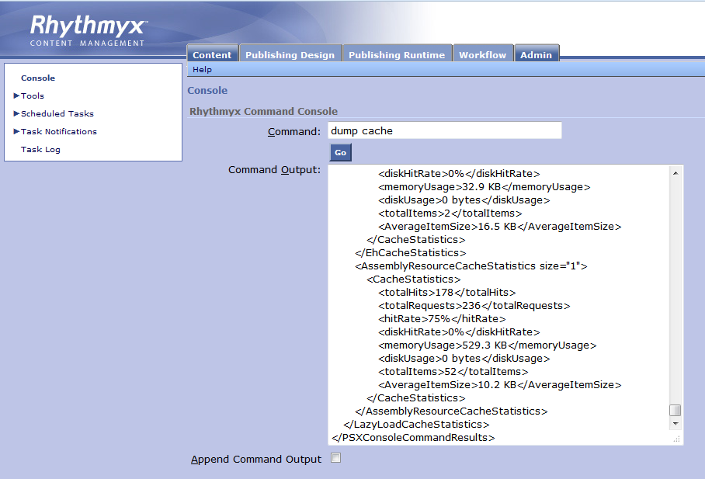
This will provide the contents of each cache, the number of items in each cache, and the cache’s memory and disk space usage.

Configuring the caches:

In order to change the amount of items each cache will store, edit the “maxElementsInMemory” for the cache, save, and then restart Rhythmyx. A good indicator on what cache’s size to increase is by viewing the cache dump and finding a cache where the “totalItems” match the cache’s corresponding “maxElementsInMemory”. The system will use as many items up to that new limit, but may not reach the limit due to not having that many items.

The following caches affect performance the greatest:

PSComponentSummary, PSAclEntryImpl, PSAclEntry_Perms, item, PSTemplateTypeSlotAssociation, PSAccessLevelImpl, and memory.

Warning:

If there is a limit on disk space, there are caches that overflow usage to disk and may cause problems if disk space has been depleted.

The caches that are at default overflowing to disk are: pubstatus, item, and PSComponentSummary. To stop overflowing to disk, edit overflowToDisk="true" to overflowToDisk="false”.

In addition if a java heap error is returned in the server log, reducing the “maxElementsinMemory” for cache’s using the most memory should resolve the heap error.

For any additional help in configuring or resolving issues related to ACLs, please contact support.

